**(ADDED TO PAPER)**

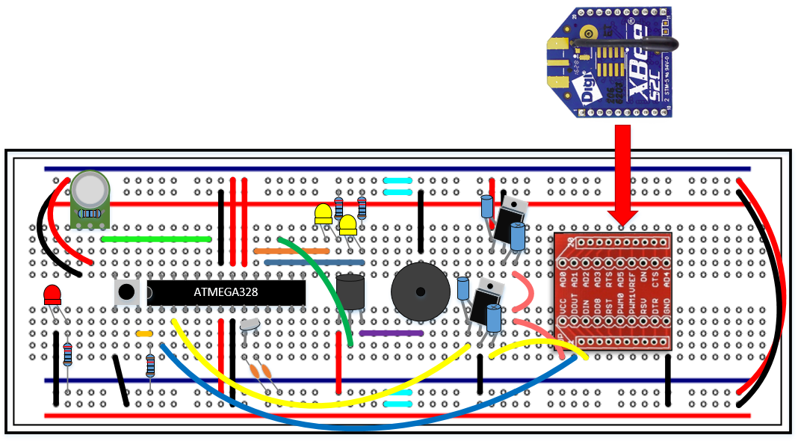

Figure 1: S.M.A.R.T Alarm Fire Alarm Module Breadboard

The image above is our preliminary breadboard representation for the S.M.A.R.T. Alarm fire alarm modules. Key components of these modules are as follows:

|  |  |  |  |
| --- | --- | --- | --- |
| Item # | Item | Quantity | Reference # |
| 1 | ATMEGA328 Microprocessor | 1 | ATMEGA 1 |
| 2 | XBEE S2C ZigBee Transceiver Module | 1 | XBEE 1 |
| 3 | 16 MHz Crystal Oscillator | 1 | X1 |
| 4 | Piezo Sounder | 1 | LS1 |
| 5 | MQ-2 Smoke and Gas Sensor | 1 | MQ2 1 |
| 6 | 3.3 – 5.0V Voltage Regulator | 2 | VR(1-2) |
| 7 | Auto Transformer | 1 | T1 |
| 8 | Light Emitting Diode | 3 | LED(1-3) |
| 9 | 22 pF Capacitor | 2 | C(1-2) |
| 10 | 10 µF Capacitor | 2 | C(3-4) |
| 11 | 100 µF Capacitor | 2 | C(5-6) |
| 12 | 220 Ω Resistor | 3 | R(1-3) |
| 13 | 5 kΩ Resistor | 1 | R4 |
| 14 | 10 kΩ Resistor | 1 | R5 |
| 15 | XBEE Breakout PCB | 1 | - |
| 16 | MQ-2 Breakout PCB | 1 | - |
| 17 | Push Button | 1 | PB1 |

**LM3940 Voltage Regulator**

The Texas Instruments LM3940 is a 1A Low-Dropout Voltage Regulator for 5V to 3.3V Conversion. The S.M.A.R.T. Alarm system requires these voltage regulators because the XBee S1 radio modules require a 3.3V operation voltage as well as 3.3V as digital input voltages. However, we are using a 5V power source, therefore causing a need for a voltage regulator. The LM3940 takes an input voltage range from 4.5V – 5.5V with a 1A output current. This regulator requires a single output capacitor to insure proper voltage regulation. The LM3940 is short-circuit protected and has an operation temperature range from -40oC to 125oC.

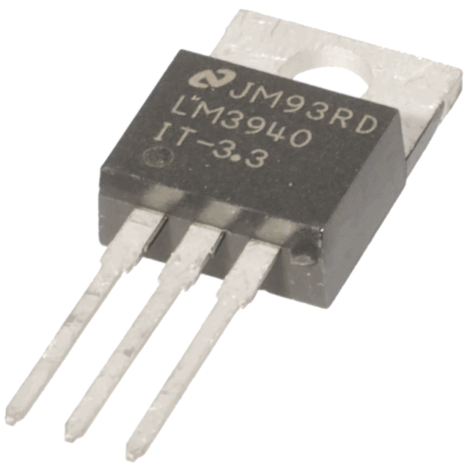 The output capacitor (minimum 33 µF) is required to maintain stability and allow for proper voltage regulation. The capacitance can be increased without limit; therefore, we chose to use a 100 µF capacitor to achieve an improved transient response. The 5V power supply must be well regulated, meaning it cannot be very noisy. If the input is in fact noisy, an additional capacitor (low ESR) can be added to the input to help improve the output noise performance.

The short-circuit protection is used to protect the low-dropout voltage regulator against high current faults or short circuits. During a current fault, the regulator sources constant current, causing the output voltage to fall when the load impedance decreases. Moreover, if a current limit occurs and the output is low, excess power may be dissipated across the regulator, triggering a thermal shutdown of the voltage regulator output. This thermal shutdown is enforced when too much heat is dissipated over the regulator. The on board semi-conductor has a thermal time-constant which is short, causing the output voltage to cycle on and off at a high rate until the power dissipation is reduced.

Figure 2: LM3940 Voltage Regulator

**Auto Transformer**

An auto transformer is a transformer with only a single winding wrapped around a core. An auto transformer is similar to a two-winding transformer; however, the primary and secondary windings are interrelated [1]. The S.M.A.R.T. Alarm fire alarm modules make use of an auto transformer to step up the voltage going into the piezo sounder, allowing the alarm to be much louder.

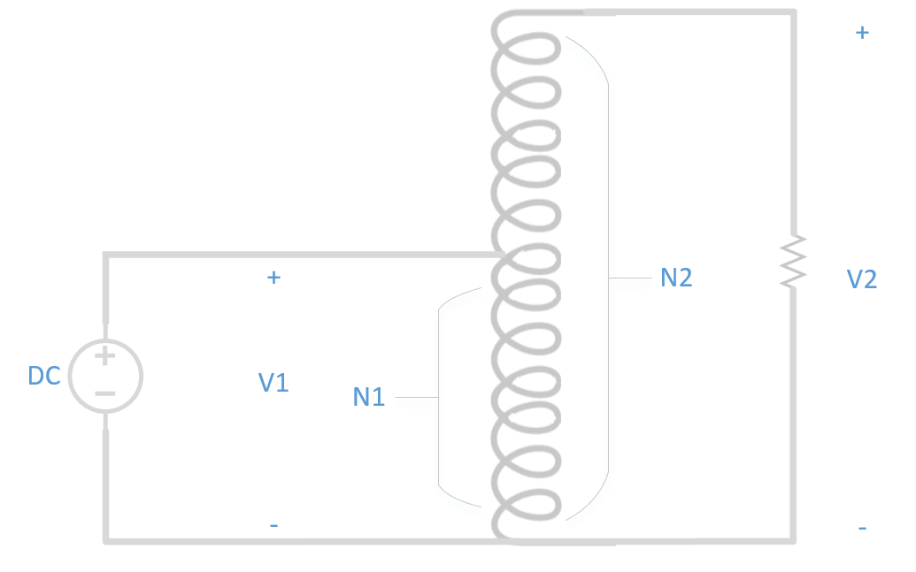 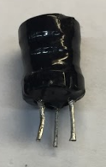

Figure 3: Step-Up Auto Transformer

This auto transformer steps up the voltage according to the ratio of turns inside the transformer. The particular auto transformer the S.M.A.R.T. Alarms are using is one with the smaller coil (8-ohms of windings) connected to a larger coil (154-ohms of winding). The 8-ohm coil is connected to the ATMEGA328 output while the 154-ohms coil is connected to the piezo sounder. This connection allows for a step up in voltage being supplied to the piezo, without the need for a higher supply voltage.

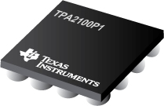The S.M.A.R.T. Alarm fire alarm modules will be utilizing these small auto transformers to boost the strength of the alarm sound. They are a cheap and easy way to step up the voltage going into the piezo sounder and can be implemented very easily. However, if the S.M.A.R.T. Alarm team decided that we want to make the sounder even louder, there are other options we can explore. A good alternat6ive to the auto transformer is the Texas Instruments TPA2100P1 19-Vpp Mono Class-D Audio Amplifier for Piezo/Ceramic Speakers. This amplifier can output a load voltage of 19-Vpp from a 2.5 V input supply. It has an integrated DC to DC converter that can generate a 10V supply with no external Schottky diode required. This amplifier comes with an integrated audio input low-pass filter as well as a small boost converter inductor to get the most out the piezo sounder. The TPA2100P1 can operate with a supply voltage range between 2.5V to 5.5V, which is perfect for use in the S.M.A.R.T. Alarm fire alarm modules. At this time, we do not believe we will require these amplifiers for our alarm modules, but they will be considered to be used if deemed necessary.

Figure 4: TPA2100P1 Audio Amplifier

**ZigBee Network Configuration**

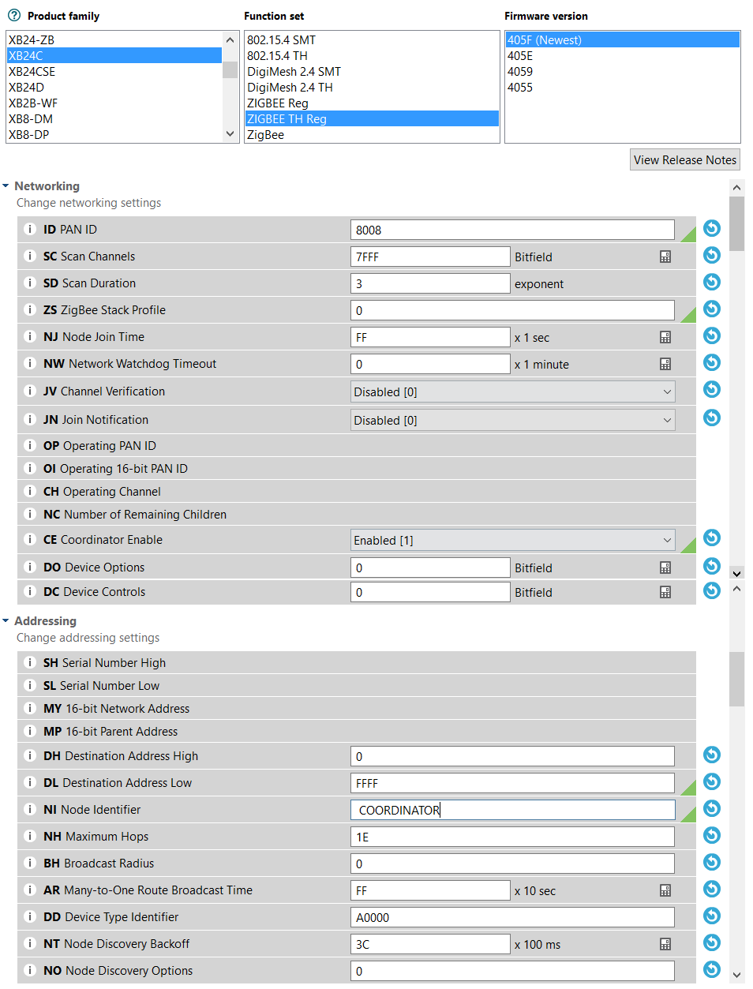The S.M.A.R.T. Alarm system will be utilizing a mesh ZigBee Network. A mesh network is composed of a single Coordinator and multiple Routers to create a wireless network. In order to configure the XBEE S2C ZigBee modules, the S.M.A.R.T. Alarm team will be utilizing the Digi International propriety software XCTU.

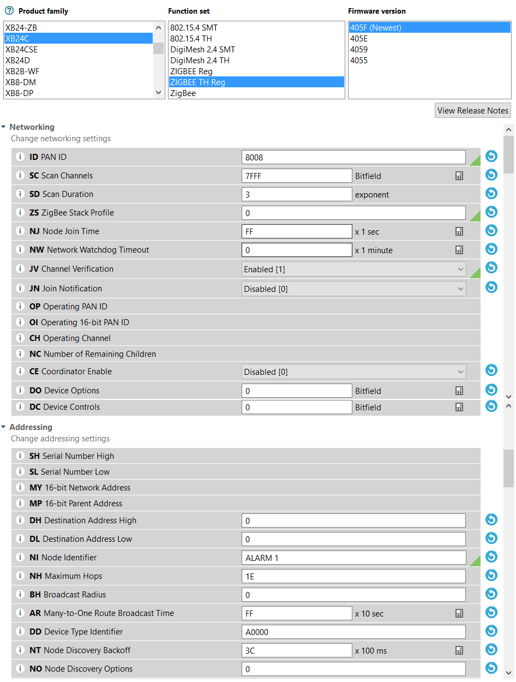First, the Coordinator must be properly configured to control and maintain the ZigBee network for all XBEE S2C modules. We first select the XB24C product family and the ZigBee TH Reg (Through Hole Regular) setup using the newest firmware version. Next we choose a PAN ID for our wireless network. This ID will be used by all XBEE modules in the network, enabling them to join and send/receive data. Scan channels should be set to 7FFE, Scan Duration to 3, Node Join Time to FF (All of which are default) and Coordinator Enable to 1. Finally, we must set the Destination Address High to 0 and the Destination Address Low to FFFF (Broadcast Mode). Figure [5] shows all the necessary steps to properly set up the Coordinator.

Figure 5: XBEE Coordinator Configuration

Next, we must set up the Router Modules. These Routers will be able to receive and transmit data to all nodes in the mesh network, enabling reliable and expansive wireless communication. We begin by choosing the XB2C Product Family and the ZigBee TH Reg as the Function set, using the newest firmware. We then match the Router PAN ID to the PAN ID we set when configuring the Coordinator. Again, we choose the default values for Scan Channels, Scan Duration and Node Join Time. We also set Channel Verification to 1 (Enable) and Coordinator Enable to 0. Finally, we set both Destination Address High and Low to 0 (the default Address Low for the Coordinator). Additionally, we can set a Node Identifier for each Router so it is possible to differentiate them.

Figure 6: XBEE Router Configuration

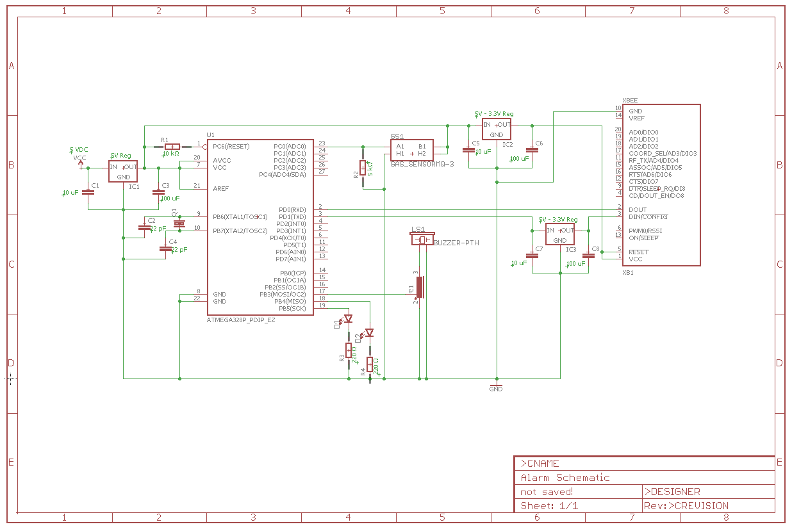

**DIGI International XCTU Software**

The S.M.A.R.T. Alarm system uses two main software applications to configure and implement the ZigBee wireless mesh network, the Arduino IDE and the DIGI International’s proprietary software XBee Configuration and Test Utility, or XCTU. XCTU is a software designed to enable developers to interact with all of DIGI International’s RF modules through a user friendly graphical user interface (GUI). XCTU has tools that allow the user to add as well as search for XBee® modules through a computers COMM ports. This tool makes it simple to configure and test all XBee RF modules, making it indispensable for developers trying to utilize DIGI’s XBee® modules to configure and implement a wireless ZigBee network. Configuring ZigBee devices is a very simple using the XCTU software, enabling the user to configure devices to connect to each other over a single PAN, as well as allowing the setup of Coordinators, Routers and End Devices, the three components of a ZigBee network. Using this software, one can assign network IDs, enable/disable channel verification, assign wireless channels, update module firmware and even give each node in a wireless network a unique node name for easy referencing. The S.M.A.R.T. Alarm team will be using the 6.3.5 version of the XCTU software.

The 6.3.5 version of the XCTU software has additional features that gives additional user support and functionality, making configuring XBee® devices extremely simple. There are three main working modes in the XCTU software; Configuration, Consoles and Network. The Configuration working mode is used to configure a radio module from the device list. To add a device to the device list you can either use the Add Devices to manually add a device or the Discover Devices tab to scan the computers COMM ports for XBee® RF devices [Figure 7]. Once a device is connected and discovered, you can begin configuring said device in the Configure working mode. Here you can adjust the PAN ID, Network settings, Node Identifier. Etc. as well as setting the module to be either a Coordinator, Router or End Device. The software gives the feature to read the firmware settings currently on the module, write new firmware settings to the module, load default firmware setting on to the module, update existing firmware and the option to create and load a firmware configuration (enabling the same firmware to be easy installed on multiple modules).

The next tab (Figure [7] to the right) is the Console working mode. The Console working mode allows users to interact or communicate with selected radio modules. Upon clicking this mode, XCTU will display a list of consoles with one entry for each module connected on the devices list. Each tab on the list displays the name of the device and its MAC address. One a module is selected from the device list, the console associated with that module moves to the front of the display. The console is either an API console or an AT console, depending on the module selected. Here you can send and receive frames as well as view the sent and received frames of the module. You can also construct data packets, which is useful for the S.M.A.R.T. Alarm system, allowing the hub and alarms to have predefined packets to send depending on the situation.

The final tab (Figure [7] far right) is the Network working mode tab, the most important feature of XCTU when it comes to setting up your wireless network, The Networking working mode allows the user to discover and view the topology of a network. This feature will only work for modules operating in the API mode. Modules operating in AT mode are not supported in the network discovery process. Once you commence a network scan, XCTU will display the status of the network. This included the number of nodes connected to the network, PAN ID, Channel, current scan number, and time of scan. After a scan is complete, you can look at the current network configuration in either a graphical or table representation of the collected data. Both representations enable the user to see which nodes in the network are connected to which and how all the data is being sent (data paths). The data also shows the signal strength of each node, on a scale from 0 to 255, 255 being the strongest possible connection. Along with checking network status you can change the network configuration of the ZigBee network using the “Layout” tab. Here you can select many different network options, including composite, spring, tree, grid or radial. The S.M.A.R.T. Alarm system will utilize the composite or mesh network configuration.

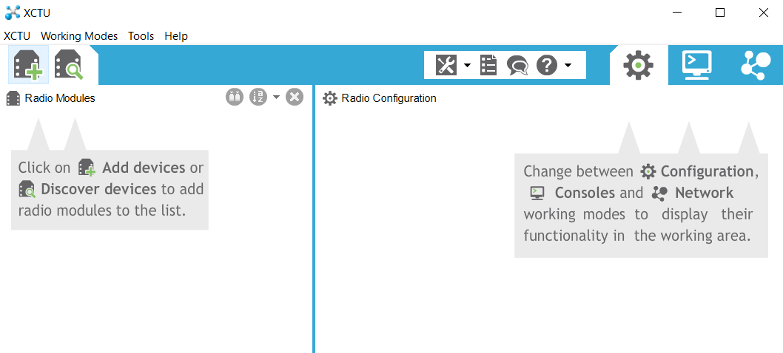

Figure 7: XCTU Software

**Implementing the Network**

Implementing a network can be split into three processes; Gathering Data, Sending Data and Receiving Data. There are established coding libraries that assist in these processes, as well as reading a plethora of different sensor data. Coding standard should be followed when implementing a network to support ease of use and to ensure a successful network.

**Sending and Receiving Data over ZigBee Mesh Network**

The ZigBee protocol is popular for many reasons, one of the biggest reasons is how a ZigBee network will automatically detect the most efficient path of data transmission from one node to another to ensure data transfer success. The S.M.A.R.T. Alarm system utilizes a mesh network to send and receive data. A mesh network is unique in the fact that it can self-adjust and connect to all other nodes, much different than a hierarchical system such as a tree network. Any device in a mesh topology may attempt to connect to any other device either directly or by using router devices to relay messages throughout a network in behalf of the original transmitting device. The route that data travels in a mesh systems is dynamic, meaning there is no set path for data to travel from one device to another. The route of the data is created on demand and can be modified if the network environment were ever to change. A mesh network has the ability to create/modify data paths dynamically, which increases both the range of the network and the reliability of the wireless connections.

The selection of a data path that the messages in a network will be relayed to their destinations is called routing [2]. The Coordinator and Routers in a ZigBee network are the devices responsible for finding and maintaining the routes in the network (an End Device cannot create routes). The distance of routes is described as the length of a path. A length is the number of devises in a particular data path. Additionally, two consecutive devices in a data path is called a link. Factors such a length, link quality, number of hops and energy conservation are all used to find the optimal data path for every routing scenario. In order to make this process as simple as possible, each link is assigned a link cost. There is a probability of success packet for each link to assign links their appropriate costs. The lower probability of success a link has, the higher the link cost. Routers are chosen based on the lowest link cost.

Data is send through a network when a data request is detected by a device. A data request can come I many different formats. These formats include broadcast, multicast or unicast with or without end to end acknowledgment. Broadcast transmission of data originates at a single node, and is then sent through all nodes in a network in a defined radius of the originator. A broadcast is used when a message is needed to be received by all devices in a network listening to a specific channel, no matter their address or PAN ID. To achieve this broadcasting effect, the destination address of the data packet must be set to 0xFFFF (Broadcast PAN ID) so that when a device receives this packet, it will send it on to the neighboring nodes as well as sending an acknowledgment back to the sender. In larger ZigBee networks, is would be hard and unnecessary for every device to send back an acknowledgment to the sender, therefore, only Coordinators and Router will send acknowledgments. In order to confirm that the data packet was broadcasted successfully, the ZigBee network makes use of “passive acknowledgment” [2]. In passive acknowledgment, after a device broadcasts a message, it will go into receive mode and wait until the same packet is rebroadcasted by any of its neighboring nodes. If the device detects a rebroadcast, it is confirmation that the message was send successfully.

Multicasting is the process in which a message is delivered to a group of devices within a single network instead of the whole network. Each of these multicast groups is identified by a 16-bit multicast group ID. Devices in a single multicast group are called group members. It is possible for a single device to be a group member of multiple multicast groups. Each device keeps track of what groups it is a part of in their individual multicast table (nwkGroupIDTable). It is possible for devices that are not members of a group to send messages to a multicast group, such as a light switch sending messages to multiple lights. It is a ZigBee standard that only data frame transmission is allowed using multicast. Therefore, no command frames are allowed to be transmitted using multicast.

Unicasting is the process of choosing a single destination to send a data packet. To do this, the destination address of the receiving device must be known. Unicasting is the most efficient way of transferring data through a network, and it can be very fast depending on routing and connection strength. The S.M.A.R.T. Alarm system will make use of all of these network communication mechanisms, using Unicast to send smoke sensor data the main hub and using broad cast to send the path planning and sound cascading data to the Alarm modules from the main hub.

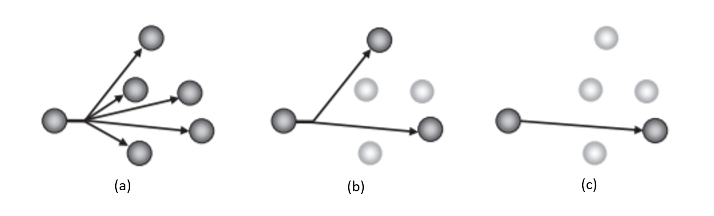

Figure : (a) Broadcast, (b) Multicast, (c) Unicast

[1] <http://circuitglobe.com/what-is-an-auto-transformer.html>

[2] http://www.chiaraburatti.org/uploads/teaching/ZigBee-Libro.pdf